|  |
| --- |
| SETTING USER PERMISSIONS |

Our users are now loose in the system with all the privileges of a *Super Admin* but we only want our users to access certain sections of the system. Here’s where Cobalt’s permissions system comes into play with “User Passports” and “User Roles”

**CREATE A NEW USER ROLE**

A user who can only access the “Character” pages cannot fit under the *Super Admin* or *System Admin* role privileges. For this we will need to create a new user role that can accommodate these specific restrictions. Navigate to the “User Roles” page inside the Admin sidebar.

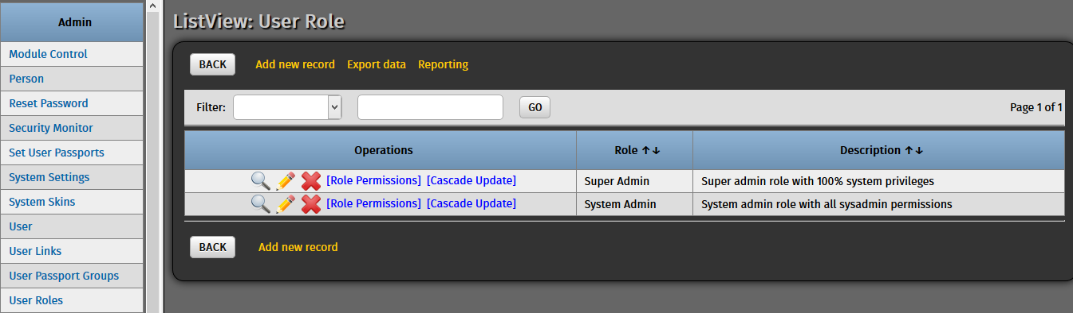

Click “Add new record” and put in entries for our new user role.

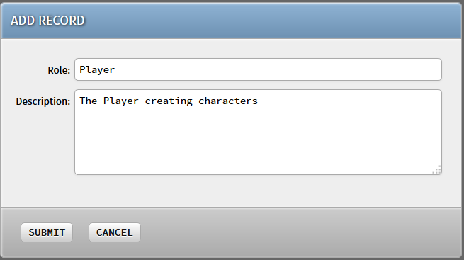

Hit “Submit” and there should be three user roles in the list now.

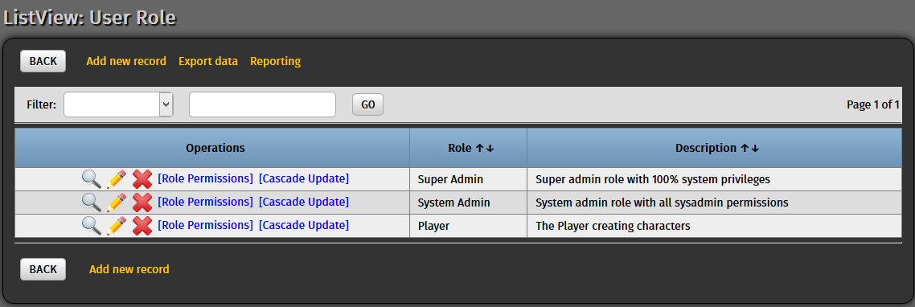

**CONFIGURING THE USER ROLE**

With the new User Role created we can fine-tune the modules that the user is allowed to access. Click on the “Role Permissions” operation beside the “Player” User Role to modify this user role’s privileges.

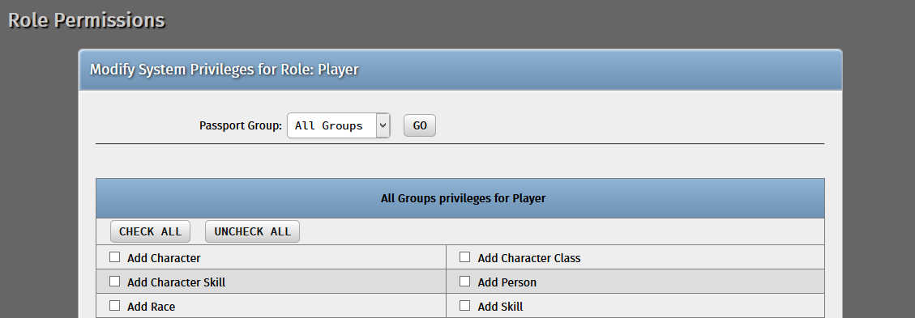

By default, new User Roles start with no privileges, so we need to manually assign that. Navigate through the list of modules and check the “Add Character”, “Character”, “Delete Character”, and“Edit Character” modules.

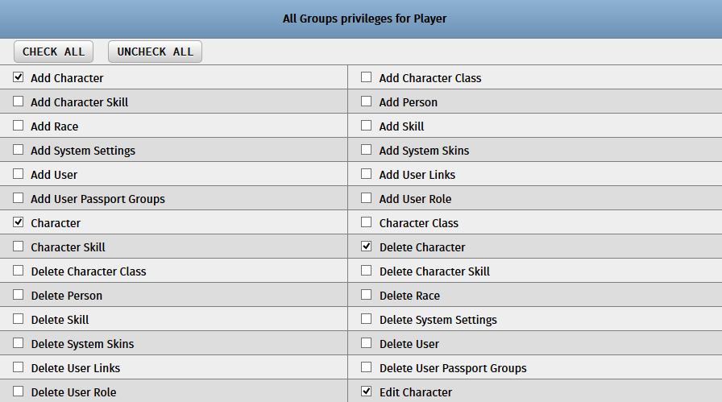

Hit “Submit” and the new role is now ready for assignment to users.

**ASSIGN THE ROLE TO USERS**

With the “Player” User Role now in place, we can re-assign the user we created earlier to this new User Role. Navigate to the User page once again and click the pencil icon beside the custom user we created (userone) to edit his details.



In the “Role” field, the new User Role should now be available as part of the list. Set the user’s role to that one.

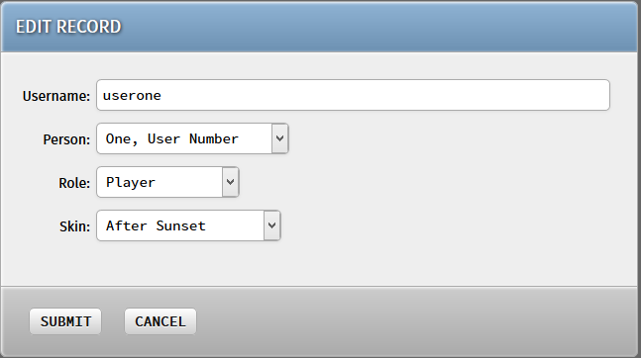

Hit “Submit” and our user should now have his new privileges ready for him. Log out (or open a new private browser window) and log back in to the system using our player user’s credentials once again.

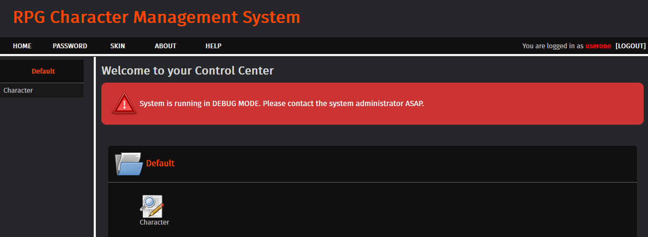

Note that only the Character modules are visible and navigable to our new user. Attempting to access other modules directly via the URL (for example, <http://localhost/rpg_char_system_1/modules/character/listview_character_class.php>) would result in a security error and would cause you to be logged out of the system as if you were accessing a disabled module.

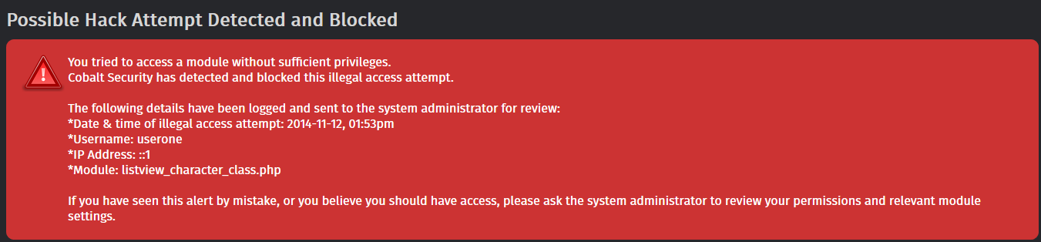

**SETTING PERMISSIONS ON A PER-USER BASIS**

Sometimes the User Role module works to cover the basic permissions and privileges that a particular group of users can do. However, there are some users that may require a little extra permission than what their current User Role allows. This is where Cobalt’s User Passports module come in to fine-tune permissions on a per-user basis.

Navigate to the “Set User Passports” page from the Admin sidebar.

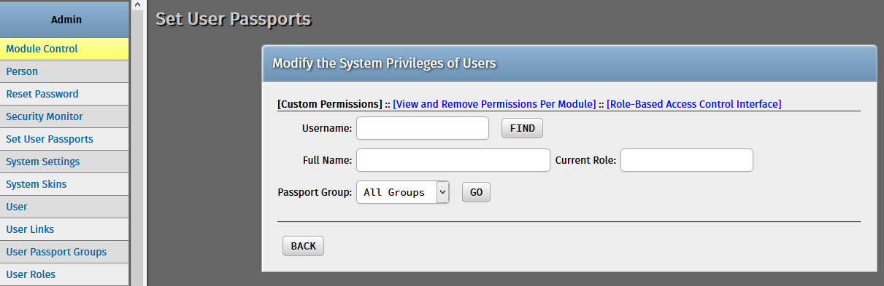

Here you can look up users either by username, full Person name, or User Role. For now let’s fine-tune our custom user further. Look him up using his username.

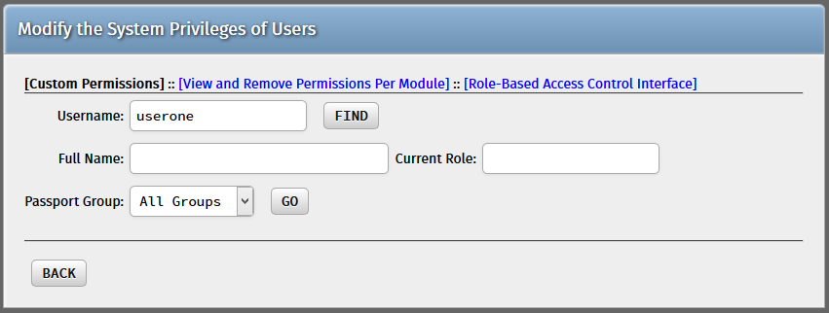

Hit “Find” and our user’s permissions list would appear in an interface similar to the one we used a while ago on the User Roles page. Let us grant our custom user permission to access the Skills modules (“Add Skill”, “Delete Skill”, “Edit Skill”, “Skill”).

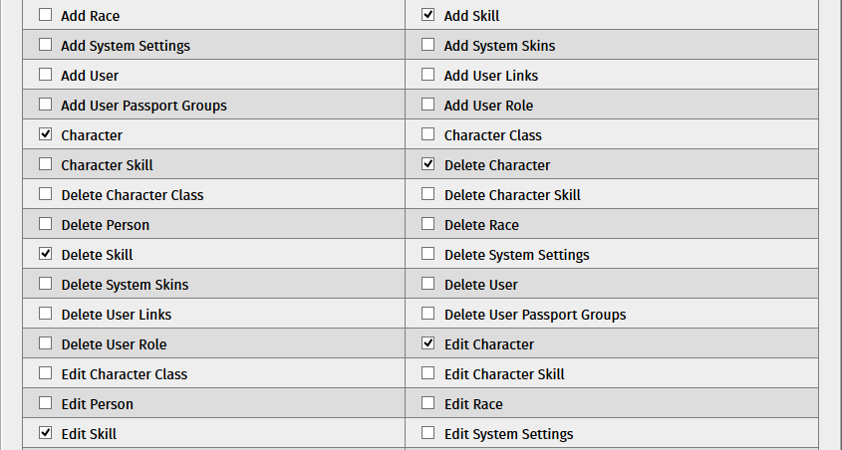

Hit “Submit” and our custom user should now be able to access the module that he was not authorized to do so earlier.

